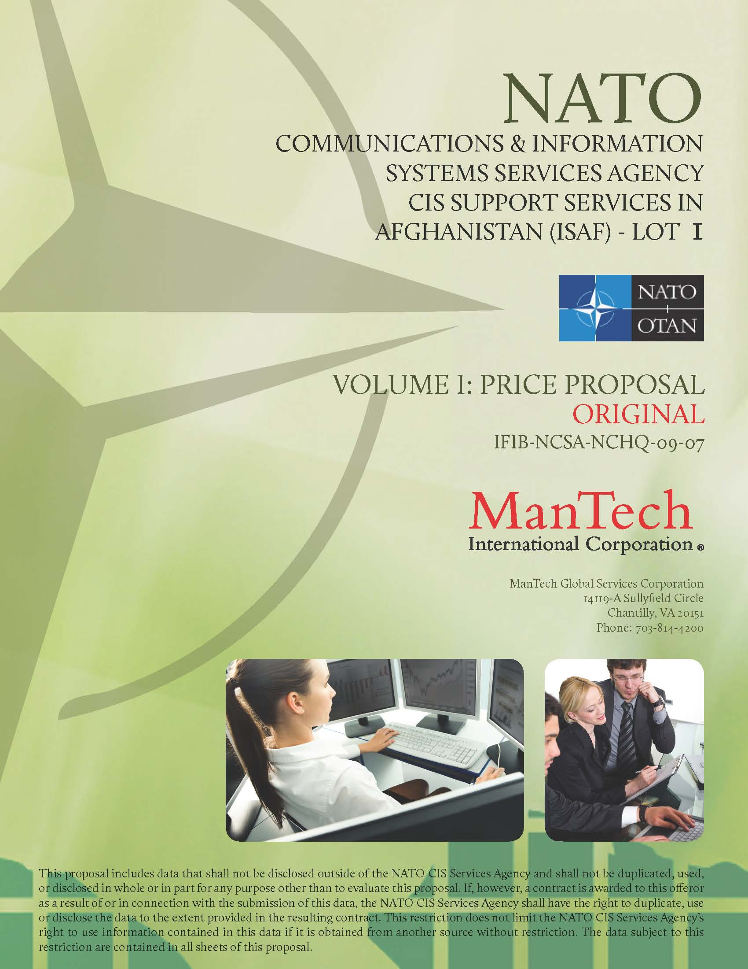
NATO
Communications & Information Systems Services Agency
CIS Support Services in Afghanistan (ISAF)
Price Proposal
OriginaL
October 14, 2009
In Response to:
IFIB-NCSA-NCHQ-09-07

Prepared by:
ManTech Telecommunications and Information Systems Corporation (MTISC)
14119-A Sullyfield Circle
Chantilly, VA 20151
Phone: (703) 814-4200

A subsidiary of


This proposal includes data that shall not be disclosed outside of the Government and shall not be duplicated, used, or disclosed in whole or in part for any purpose other than to evaluate this proposal. If, however, a contract is awarded to this offeror as a result of or in connection with the submission of this data, the Government shall have the right to duplicate, use, or disclose the data to the extent provided in the resulting contract. This restriction does not limit the Government’s right to use information contained in this data if it is obtained from another source without restriction. The data subject to this restriction are contained in all sheets of this proposal.
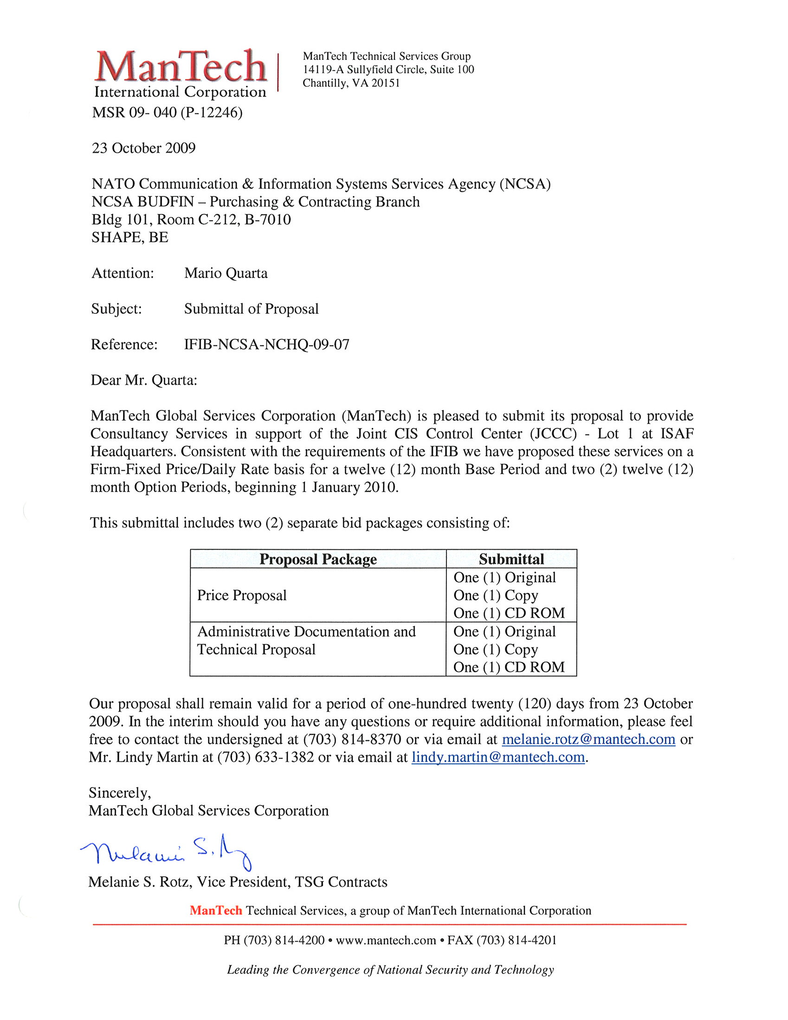
[cover letter]
Contents
1. Pricing Methodology 1
1.1. Overview and General Information 1
1.1.1. Company Information 1
1.1.2. Contract Type 1
1.1.3. Contract Effective Date 1
1.1.4. Proposal Validity 1
1.1.5. Period of Performance 1
1.2. Pricing Methodology 2
1.2.1. Estimated Level of Effort 2
1.2.2. Direct Labor 2
2. Administrative and Financial Information 3
2.1. Organizational Structure and Backup Capacity 3
2.2. ManTech Licensed and Registered Independent Contractor 4
2.3. Compliance with Delivery and Performance Schedule 5
2.4. Compliance with Workmen’s Compensation/Employees’ Liability 5
2.5. Compliance with Civil Liability Insurance 5
2.6. Performance Bond/Bank Guarantee 5
2.7. Profit and Loss Statements 5
3. Pricing Detail 6
3.1. Enclosure 1 to Part 1 Lot 1 6
4. Solicitation Documents 9
4.1. Enclosure 1, Part 1 Summary 9
5. Performance Bond/Bank Guarantee 12
6. Profit and Loss Statements 16

Tables
Table 1. Company Information 1
Table 2. Period of Performance 2

- Pricing Methodology
  - Overview and General Information
ManTech Global Services Corporation (ManTech) is pleased to provide our Price Proposal for Consultancy Services for CIS Support, in response to NCSA Solicitation Number IFIB-NCSA-NCHQ-09-07. This information is intended to provide NCSA with an understanding of the basis for our proposed Firm-Fixed Price (FFP)/Indefinite Delivery Indefinite Quantity (IDIQ)/Indefinite Delivery Indefinite Quantity (IDIQ)/Indefinite Delivery Indefinite Quantity (IDIQ) Indefinite Delivery Indefinite Quantity (IDIQ) amount, which we believe represents the lowest realistic and reasonable price to effectively and efficiently accomplish NCSA’s mission.
The data submitted herein is in compliance with ManTech’s policies and represents a comprehensive evaluation of the resources necessary to perform the solicitation requirements. To accomplish the mission, we have enlisted the services of our subcontractor Segovia, Inc. to complete the ManTech Team.
ManTech has taken no exceptions to, nor has deviated from the terms and conditions of, the solicitation. This proposal is fully responsive to the requirements of the solicitation and is valid for 120 days from the closing date of the solicitation.
    - Company Information
As required in the solicitation, ManTech’s company information is provided in Table 1.
Table 1. Company Information
Entity | Information
ManTech Company | ManTech Global Services Corporation  TIN: 125539358  DUNS No.: 809578615
Parent Company | ManTech International Corporation  12015 Lee Jackson Highway  Fairfax, VA 22033-3300
Administrative Office | ManTech Global Services Corporation  14119-A Sullyfield Circle  Chantilly, VA 20151
Authorized Negotiators | Louis M. Addeo, President  Bonnie J. Cook, Sr. Vice President  Deborah A. Thurman, Sr. Vice President  Melanie S. Rotz, Vice President

    - Contract Type
ManTech has proposed this effort on a FFP/IDIQ basis in accordance with the solicitation requirements.
    - Contract Effective Date
ManTech has proposed this effort based on a contract effective start date from contract execution start date (November or December 2009), or not later than January 1, 2010.
    - Proposal Validity
This proposal will remain valid for 120 days from the closing date of the solicitation.
    - Period of Performance
This proposal is based on the award of a contract that includes a three-year contract period of performance and two one-year options. The specific dates for performance are outlined in Table 2.
Table 2. Period of Performance
Period | Start Date | End Date
Period 1 | From contract execution start date, or not later than January 1, 2010 | December 31, 2010
Period 2 | January 1, 2011 | December 31, 2011
Period 3 | January 1, 2012 | December 31, 2012

  - Pricing Methodology
ManTech is pleased to provide the following pricing methodology information delineating the basis and rationale for our proposal. The estimating basis for each element of cost included in our proposal is discussed in the following subsections.
Please note that ManTech’s proposal has been prepared using the proposed subcontractor’s fully burdened prices.
    - Estimated Level of Effort
The proposed level of effort is based on the level of effort proposed in the Statement of Work. ManTech understands that this level of effort could increase or decrease throughout the life of the contract.
    - Direct Labor
ManTech’s approach is to provide the most highly qualified personnel at realistic labor rates and fringe benefits. This is critical since labor cost is the single largest cost element in a services contract of this nature. ManTech is dedicated to the delivery of the highest quality services possible. To achieve this, the most knowledgeable and experienced personnel are necessary and must be compensated accordingly. In both professional and technical fields of labor required for this effort, only the best candidates are recruited and hired. ManTech compensates our employees, both in wages and benefits, with realistic and reasonable compensation packages. This translates to lower costs by increasing retention and morale while reducing training and transition costs. ManTech has a proven track record with this approach.
- Administrative and Financial Information
  - Organizational Structure and Backup Capacity
ManTech International Corporation is a leading provider of IT and CIS solutions to NATO and U.S. Federal Government agencies, focusing primarily on mission-critical national defense programs. Our expertise includes consulting and advisory technical services, communications system integration and sustainment, software development, enterprise security architecture, information assurance, intelligence operations support, network and critical infrastructure security and IT/engineering support. ManTech commands a global presence and currently employs more than 8,000 employees with $1.9 billion in annual sales. ManTech currently has a European-based workforce of more than 400 personnel supporting both NATO and DoD programs, and has maintained a European-based workforce since 1982. Currently, ManTech is successfully supporting NATO operations on more than 100 separate contracts and task orders, such as those cited in our past performance, proposal Section 4.1.
MGSC is a separate and legal entity organized under ManTech’s Technical Services Group (TSG), which is under the parent company. ManTech has obtained all authorities required to operate and do business with NATO. ManTech’s key management personnel provide strong corporate leadership for this effort (Figure 2). Mr. Louis Addeo is president of the ManTech TSG, the company's largest business unit. Mr. Michael Polmar, senior vice president, TSG reports directly to Mr. Addeo and is ultimately responsible for the success of all NATO programs. ManTech TSG is located in Chantilly, VA (USA); with its MGSC offices in Chantilly, VA (USA) and Brussels, Belgium. Mr. Lindy Martin, the executive director for NATO programs, is primarily responsible for the operational leadership on all NATO contracts and reports directly to Mr. Polmar.
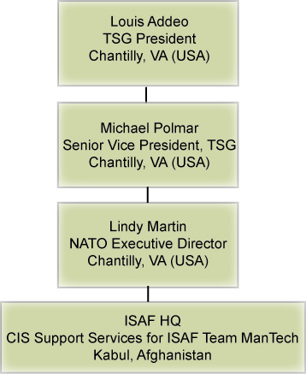
Figure 2. ManTech MGSC TSG Organizational Structure
Mr. Martin is the proposed program manager (PM) for the CIS Support Services for ISAF in Afghanistan, Lot 1 and is responsible for overall project success. He will coordinate with NATO leadership on all issues, resolutions, and changes. With more than 37 years of experience in providing expert consultancy support to NATO, Mr. Martin has a proven, highly regarded reputation for professionalism and program success. He has demonstrated leadership on many similar contracts and has complete authority to commit ManTech technical resources to meet JCCC requirements. He is the first POC should there be concerns or issues with the contract and he will work with the onsite personnel until the situation is resolved.
ManTech has established a fully functional office in Brussels, Belgium to further support our NATO customers, and our employees, consultants, and sub-contract team. The Brussels office is staffed with resource personnel who will support program requirements and allows our team to provide a quick response and superior back office support to all our NATO customers.
ManTech's proposed CIS Support Services for ISAF Program Management Organization (PMO) is outlined in Figure 3, and Administrative/PMO personnel resumes are included in proposal Appendix A.
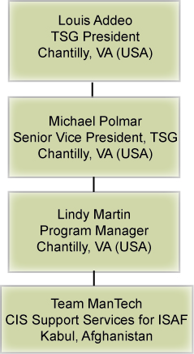
Figure 3. Team ManTech’s CIS Support Services for the ISAF PMO
As a subcontractor on Lot 1, Segovia will assign a Program Management Institute (PMI)-certified PM to act as the single point of contact to ManTech (Figure 4). The PM will work with our supplied resources to ensure adequate supply and any transition, if necessary. In the event that a resource would leave after his or her term is complete, Segovia will present multiple candidates for selection to both ManTech and NCSA.
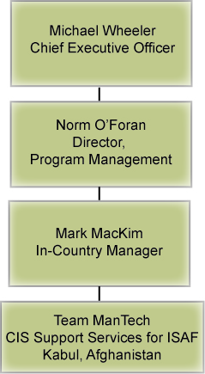
Figure 4. Segovia’s CIS Support Services Organizational Structure
  - ManTech Licensed and Registered Independent Contractor
In response to Bidding Instructions, paragraph 11.2, b, (8), (b), ManTech and Segovia certify they are legally licensed and registered as independent contractors at work and in travel and have authorization to perform the tasks associated with IFIB-NCSA-NCHQ-09-07. ManTech and Segovia’s incorporation certificates are provided in Technical Proposal Appendix B.
  - Compliance with Delivery and Performance Schedule
ManTech and Segovia certify we are able to comply with the required or proposed delivery or performance schedule, taking into consideration all existing commercial and business commitments in accordance with Bidding Instructions, paragraph 11.2, c, (8), (c).
  - Compliance with Workmen’s Compensation/Employees’ Liability
In response to Bidding Instructions, paragraph 11.2, c, (8), (d), ManTech certifies that we have Workmen’s Compensation coverage at $1,000,000.00 per accident.
In response to Bidding Instructions, paragraph 11.2, c, (8), (d), Segovia certifies to the following coverage:
- Virginia Worker’s Compensation: $1,000,000.00 for bodily injury by accident/disease
- General Liability: $1,000,000.00 each occurrence for Person/Property
- Umbrella Policy: $15,000,000.00 Limit for claims in excess of above
ManTech and Segovia also provide employees’ liability through proper insurance contracts and fulfill payment obligations to the health and social security systems. ManTech’s and Segovia’s certificates of Insurance are provided in Technical Proposal Appendix C.
  - Compliance with Civil Liability Insurance
In response to Bidding Instructions, paragraph 11.2, c, (8), (e), ManTech certifies to the following comprehensive general liability insurance coverage:
- $2,000,000.00 per occurrence, per person (bodily injury)
- $1,000,000.00 per occurrence (bodily injury)
- $300,000.00 per occurrence (property damage)
ManTech's Certificate of Insurance is provided in Technical Proposal Appendix B.
In response to Bidding Instructions, paragraph 11.2, c, (8), (e), Segovia certifies to the following general liability insurance coverage:
- $1,000,000.00 per occurrence, per person (bodily injury)
- $1,000,000.00 per occurrence (bodily injury)
- $300,000.00 per occurrence (property damage)
Segovia’s Certificate of Insurance is provided in Technical Proposal Appendix C.
  - Performance Bond/Bank Guarantee
A statement is provided from ManTech’s bank in Price Proposal, Section 5, stating it is willing to immediately provide NCSA with the required performance bond/bank guarantee upon request, per Bidding Instructions, paragraph 11.2, c, (8), (f).
  - Profit and Loss Statements
ManTech’s profit and loss statements for the past three financial years are provided in Price Proposal, Section 6. Segovia is a privately owned company; publication of profit and loss statements is not compulsory.

- Pricing Detail
  - Enclosure 1 to Part 1 Lot 1

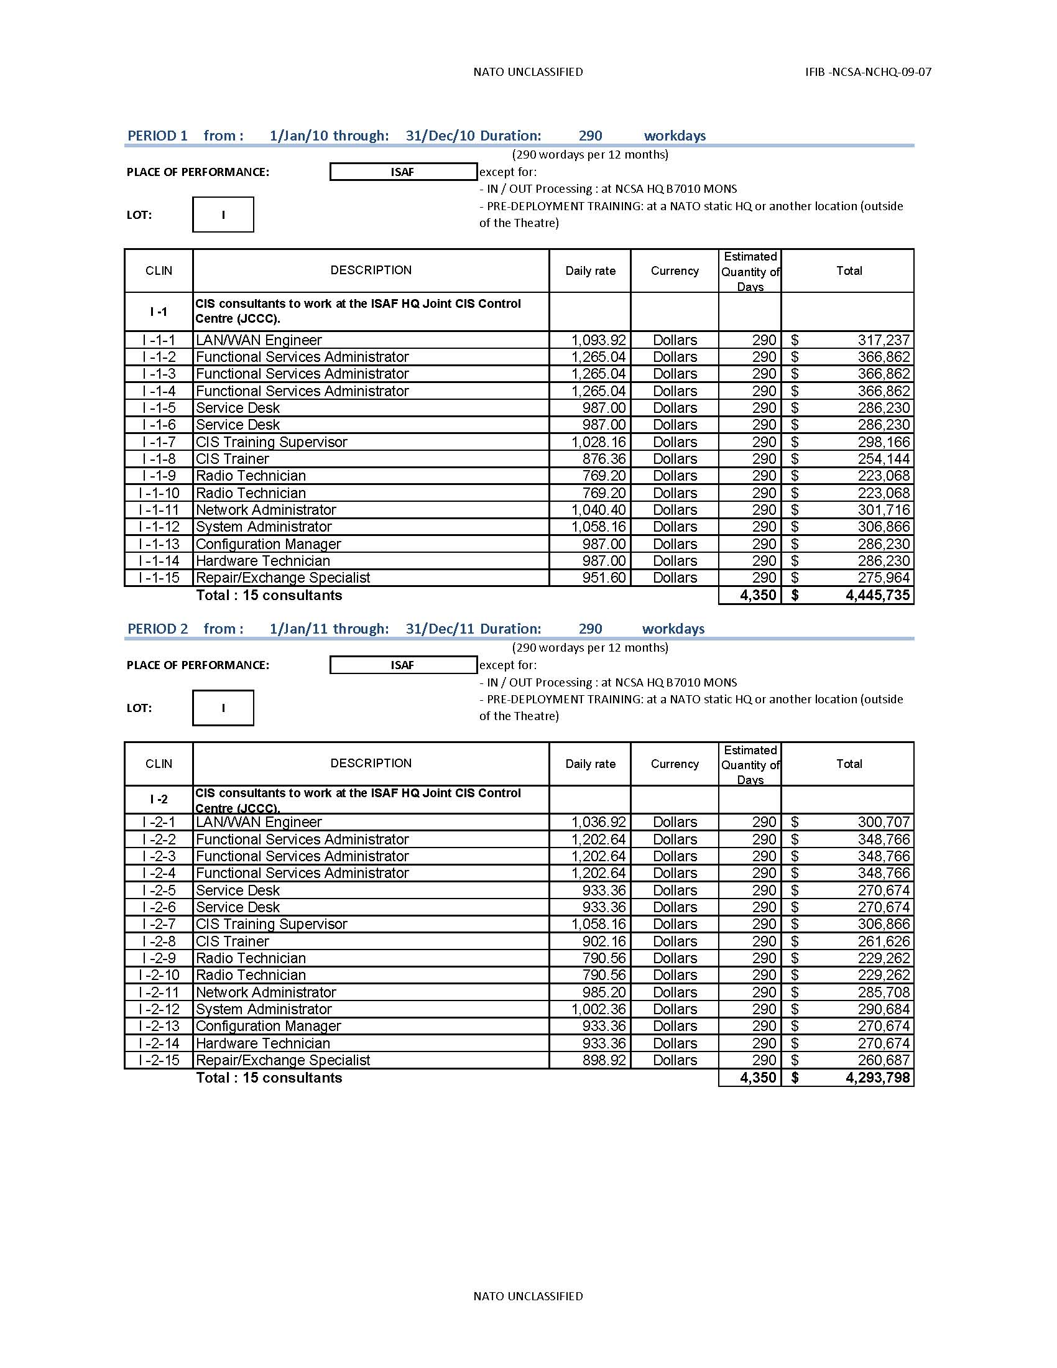
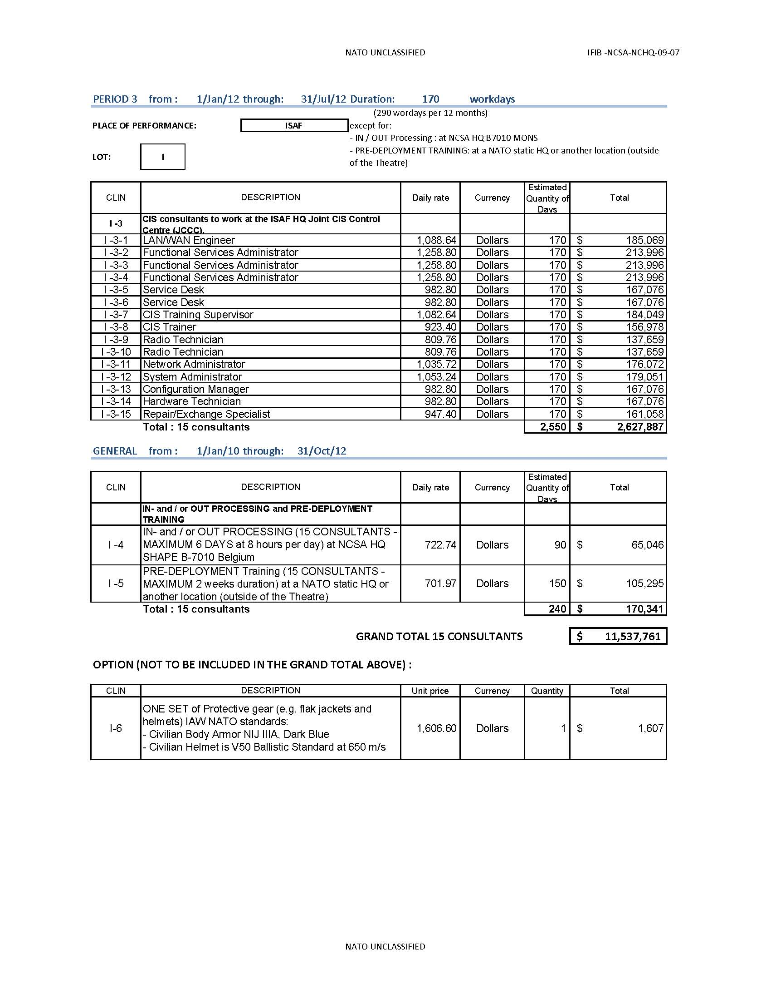
- Solicitation Documents
  - Enclosure 1, Part 1 Summary

Enclosure 1 to Part I

TOTAL PRICE (BASE + OPTION) $11,539,368.00 includes all previous pricing Currency U.S. dollars

1. BID SIGNATURE(S) in accordance with the provisions of Part I Para 12.2:

This Bid is prepared and submitted on behalf of the legal corporate entity specified below:

FULL NAME OF CORPORATION: ManTech International Corporation

DIVISION / SUBDIVISION (IF APPLICABLE): ManTech Global Services Corporation

OFFICIAL MAILING ADDRESS: 14119-A Sullyfield Circle
Chantilly, VA 20151
(703) 814-4200

TELEFAX NO: (703) 814-4385

2. POINT OF CONTACT REGARDING THIS BID:
NAME: Melanie S. Rotz

POSITION: Vice President of Contracts

TELEPHONE: (703) 814-8370

INTERNET E-MAIL ADDRESS: melanie.rotz@mantech.com

3. ALTERNATIVE POINT OF CONTACT:
NAME: Lindy Martin

POSITION: Executive Director

TELEPHONE: (703) 633-1382

INTERNET E-MAIL ADDRESS: lindy.martin@mantech.com

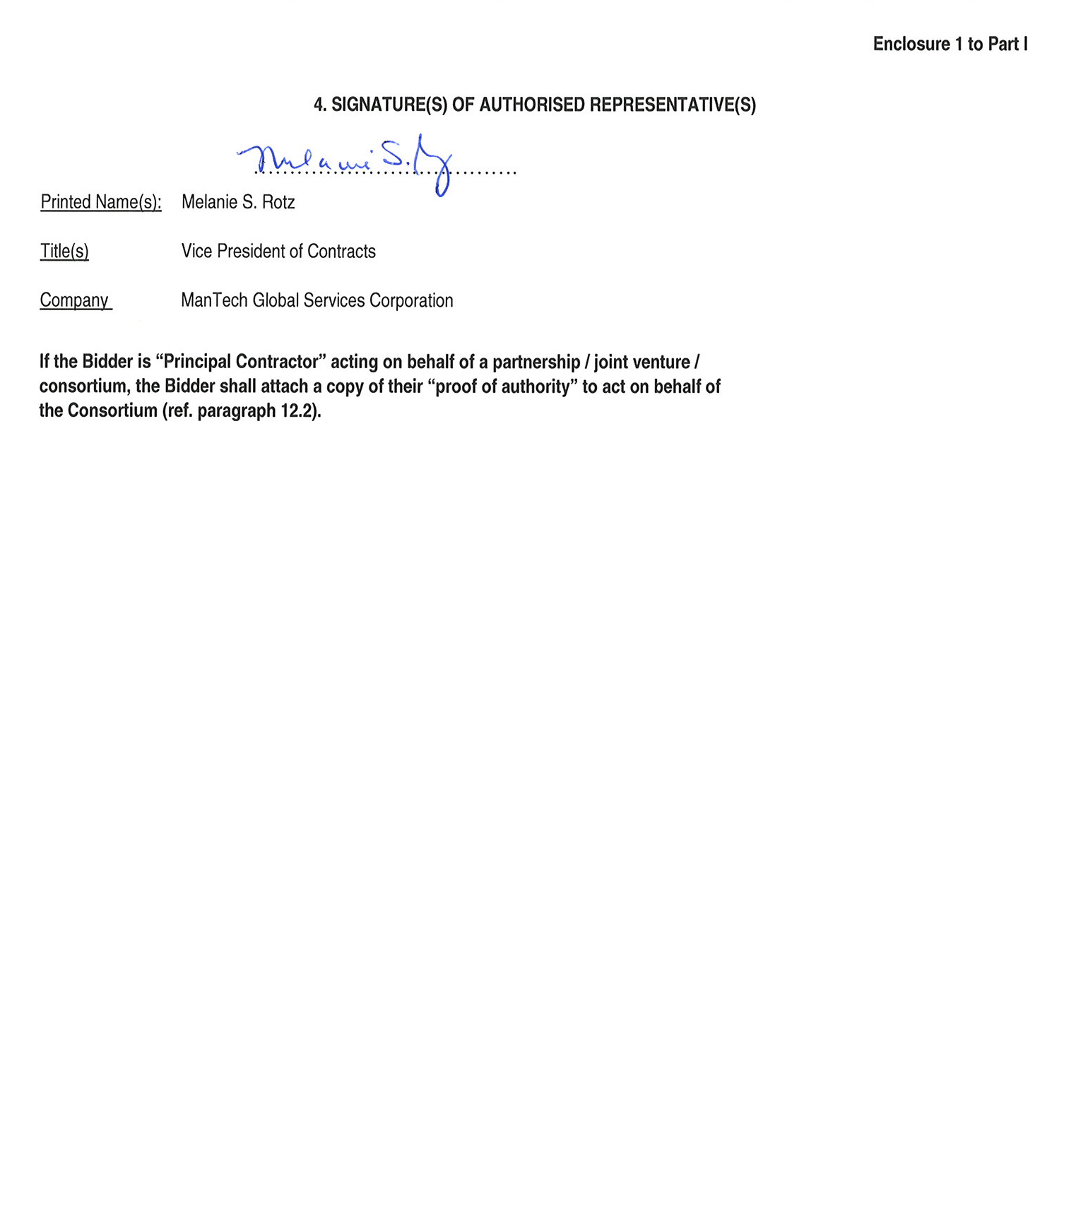
Enclosure 1 to Part I

4. SIGNATURE(S) OF AUTHORISED REPRESENTATIVE(S)

……………………………….
Printed Name(s): Melanie S. Rotz

Title(s) Vice President of Contracts

Company ManTech Global Services Corporation

If the Bidder is “Principal Contractor” acting on behalf of a partnership / joint venture /
consortium, the Bidder shall attach a copy of their “proof of authority” to act on behalf of
the Consortium (ref. paragraph 12.2).

- Performance Bond/Bank Guarantee
Note: The letter of credit from ING Bank is in process.

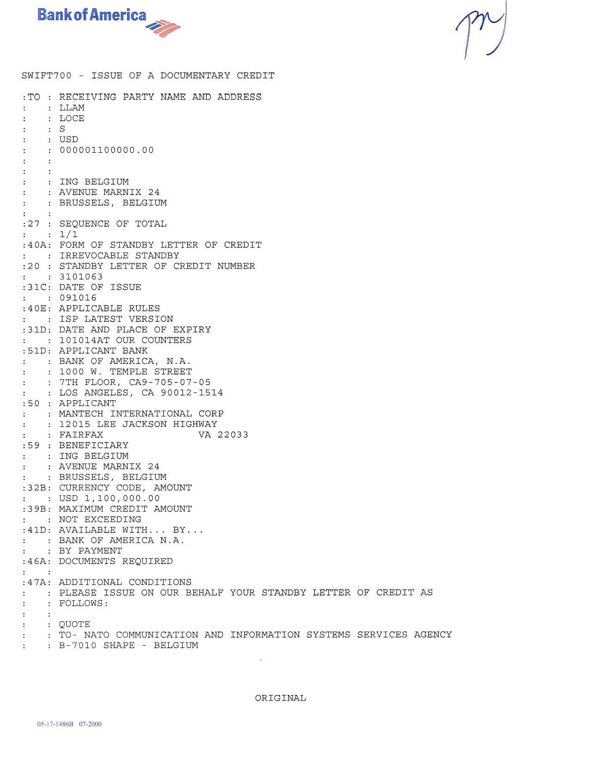
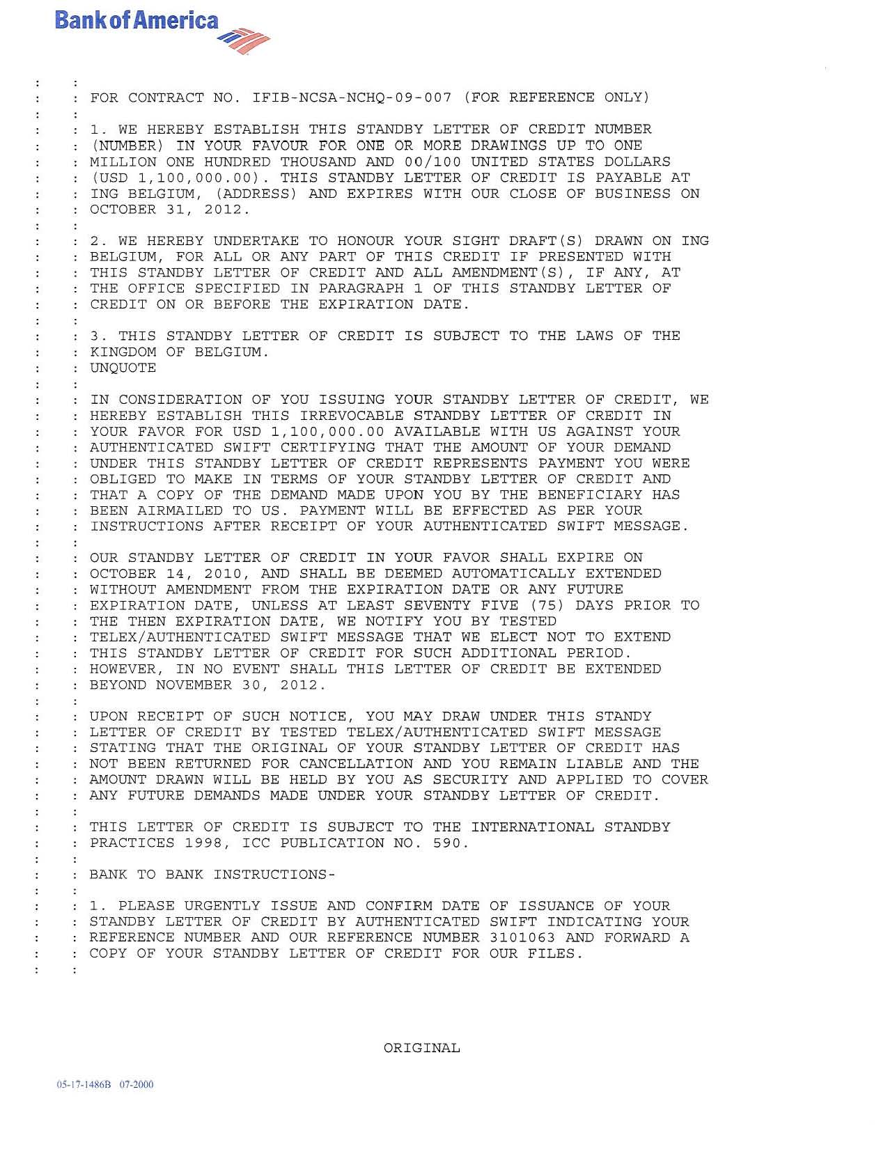
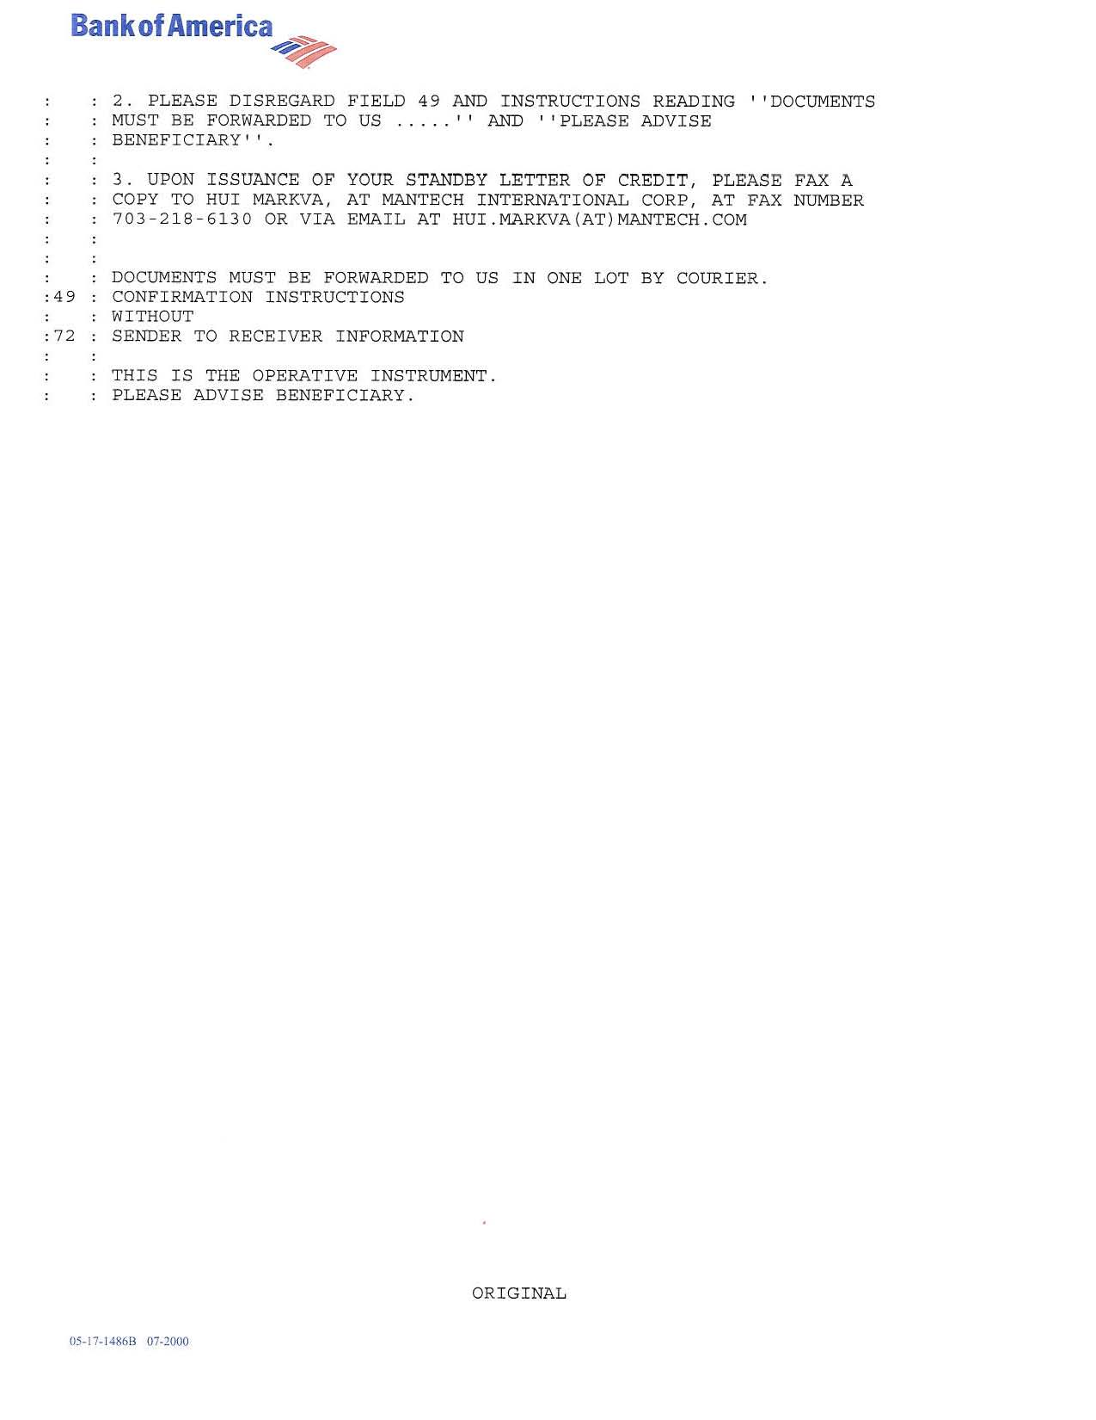
- Profit and Loss Statements

